**Therapeutic Ultrasound in Physical Therapy**

By [Brett Sears, PT](https://www.verywellhealth.com/brett-sears-2695988)

Updated on February 03, 2024

 Medically reviewed by [Laura Campedelli, DPT](https://www.verywellhealth.com/laura-campedelli-pt-dpt-4776034)

 Fact checked by [Sarah Scott](https://www.verywellhealth.com/sarah-scott-6752769)

Table of Contents

View All

Table of Contents

* [What Is Therapeutic Ultrasound?](https://www.verywellhealth.com/therapeutic-ultrasound-in-physical-therapy-2696419#toc-what-is-therapeutic-ultrasound)
* [How Does It Work?](https://www.verywellhealth.com/therapeutic-ultrasound-in-physical-therapy-2696419#toc-how-does-ultrasound-work)
* [When Is It Used?](https://www.verywellhealth.com/therapeutic-ultrasound-in-physical-therapy-2696419#toc-when-is-it-used)
* [What to Expect](https://www.verywellhealth.com/therapeutic-ultrasound-in-physical-therapy-2696419#toc-what-to-expect)
* [Contraindications](https://www.verywellhealth.com/therapeutic-ultrasound-in-physical-therapy-2696419#toc-contraindications)

Therapeutic ultrasound is a [treatment](https://www.verywellhealth.com/physical-therapy-treatments-and-modalities-2696683) commonly used in physical therapy to provide deep heating to soft tissues in the body. These tissues include muscles, tendons, joints, and ligaments.

Ultrasound in physical therapy is different than diagnostic ultrasound. With the latter, healthcare providers use ultrasound to see the inside of the body. For example, diagnostic ultrasound lets healthcare providers check on a fetus during pregnancy.

This article explains how therapeutic ultrasound works and when it's used.

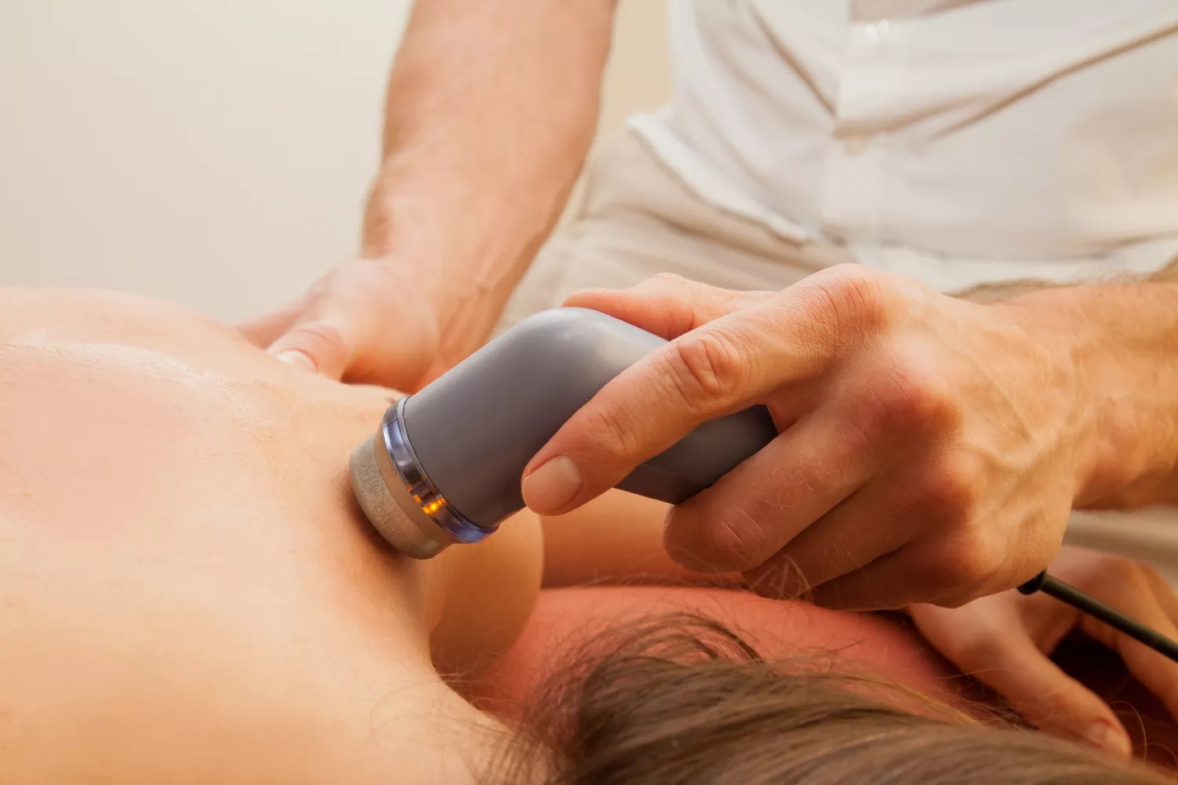

maria_esau / Getty Images

What Is Therapeutic Ultrasound?

Therapeutic ultrasound is used to heat tissues and introduce energy into the body.1

Deep Heating Effects

[Ultrasound](https://www.verywellhealth.com/ultrasound-8704216) can provide deep heating to soft tissue structures in the body. Deep heating tendons, muscles, or ligaments could have the following benefits:2

* Increase circulation to tissues
* Speed the healing process
* Decrease pain
* Increase elasticity

Deep heating can increase the "stretchiness" of muscles and tendons that may be tight.

If you have [shoulder pain](https://www.verywellhealth.com/shoulder-pain-2548793) and have been diagnosed with a [frozen shoulder](https://www.verywellhealth.com/how-do-i-know-if-i-have-a-frozen-shoulder-2696429), your physical therapist (PT) may use ultrasound. This therapy is usually done before performing [range of motion](https://www.verywellhealth.com/overview-range-of-motion-2696650) exercises because it can help improve the ability of your shoulder to stretch.

**Click Play to Learn More About the Use of Therapeutic Ultrasound**

This video has been medically reviewed by [Laura Campedelli, PT, DPT](https://www.verywellhealth.com/laura-campedelli-pt-dpt-4776034).

Non-Thermal Effects (Cavitation)

In addition to heat, ultrasound introduces energy into the body. This energy causes microscopic gas bubbles around your tissues to expand and contract rapidly, a process called cavitation.

It is theorized that the expansion and contraction of these bubbles help speed cellular processes and help injured tissue heal faster.

When cavitation is unstable, it can be dangerous to your body's tissues.3 So, your [physical therapist](https://www.verywellhealth.com/what-is-a-physical-therapist-2696641) will work to ensure that the cavitation during therapy is stable.

**Recap**

Therapeutic ultrasound uses heat and energy to increase circulation, decrease pain, increase flexibility, and speed healing.

How Does Ultrasound Work?

Inside your physical therapist's ultrasound unit is a small crystal. When an electrical charge hits this crystal, it vibrates rapidly, creating piezoelectric waves (an electric charge that accumulates in some solid materials). These waves emit from the ultrasound sound head as ultrasound waves.

During treatment, the ultrasound wave then enters into your injured tissues. This exposure to ultrasonic waves increases blood flow and cavitation, leading to the theorized benefits of the treatment.

When Is It Used?

PTs may use therapeutic ultrasound to treat some injuries and chronic pain.

Injuries

Usually, PTs treat orthopedic (musculoskeletal) injuries with ultrasound. These may include:

* [Bursitis](https://www.verywellhealth.com/physical-therapy-exercises-for-hip-bursitis-5199259) (inflammation in the fluid-filled sacs along joints)
* [Tendonitis](https://www.verywellhealth.com/tendonitis-definition-causes-treatment-2696478)
* Muscle strains and tears
* [Frozen shoulder](https://www.verywellhealth.com/first-steps-to-treat-a-frozen-shoulder-2696482)
* Sprains and ligament injuries
* Joint contracture or tightness

Generally speaking, any soft-tissue injury in the body may be a candidate for ultrasound therapy. For example, your physical therapist may use ultrasound for low back pain, neck pain, rotator cuff tears, knee meniscus tears, or ankle sprains.

Chronic Pain

There is also some evidence that you may benefit from ultrasound treatments if you have chronic pain. It is thought that the ultrasound waves help improve tissue extensibility and circulation, leading to increased mobility and, ultimately, decreased pain.4

**Recap**

PTs use therapeutic ultrasound for specific soft-tissue injuries, including joint pain, muscle strains and tears, and ligament injuries. In addition, they sometimes use it for chronic pain.

[Ultrasound Therapy for Chronic Pain](https://www.verywellhealth.com/what-is-ultrasound-therapy-2564506)

What to Expect

Ultrasound uses a machine that has an ultrasound transducer (sound head). First, a PT applies a small amount of gel to the particular body part; then, your physical therapist slowly moves the sound head in a small circular direction on your body.

**What Ultrasound Feels Like**

While receiving an ultrasound treatment, you will most likely not feel anything happening, except perhaps a slight warming sensation or tingling around the treatment area.

If the ultrasound sound head is left in place on your skin and not moved in a circular direction, you may experience pain. If this occurs, tell your physical therapist right away.

Settings

The therapist may change various settings of the ultrasound unit to control the ultrasound wave's penetration depth or change the ultrasound's intensity. In addition, they may use different settings during various stages of healing.5

Methods

Alternative methods of ultrasound application are available if the body part is bony and bumpy or if there's an open wound. (The ultrasound gel and sound head may harbor bacteria that can enter the wound.) These include:

* Direct contact (most commonly used method)
* Water immersion
* Bladder technique

Ultrasound + Medication

Your PT may use ultrasound gel combined with a topical medication to help treat inflammation around the soft tissue in the body. This process is called [phonophoresis](https://www.verywellhealth.com/therapeutic-ultrasound-in-physical-therapy-2696419).

While there is evidence that ultrasound waves help deliver the medicated gel to the injured tissues, many published studies indicate that this treatment may be ineffective.6

**Recap**

Therapeutic ultrasound does not result in many bodily sensations, other than the feeling of the ultrasound wand against your skin. Your PT may use various settings or different application methods depending on your situation.

Contraindications

There are some instances where you should not use ultrasound at all. These contraindications to ultrasound may include:789

* Over open wounds
* Over metastatic lesions (cancer that has spread) or any active areas of cancer
* Over areas of decreased sensation
* Over parts of the body with metal implants, like in a total knee replacement or lumbar fusion
* Near or over a pacemaker
* Around the eyes, breasts, or sexual organs
* Over fractured bones
* Near or over an implanted electrical stimulation device
* Near overactive growth plates in children
* Over an area of acute infection

Does Evidence Support Its Use?

Studies have been mixed as to whether or not ultrasound offers benefit to the overall outcome of physical therapy. One found that focused low-intensity pulsed ultrasound was a safe and effective treatment for relieving pain and improving quality of life in patients with knee osteoarthritis.

On the other hand, a 2014 study in the*American Journal of Physical Medicine and Rehabilitation* examined the effect of ultrasound on pain and function in patients with [knee osteoarthritis](https://www.verywellhealth.com/ultrasound-treatment-for-osteoarthitis-2552252).10 The researchers found no difference in knee function and pain with rehab using ultrasound, no ultrasound, and sham (fake) ultrasound.

Is It Right For You?

Some argue that ultrasound can harm your physical therapy by needlessly prolonging your care. So, if your physical therapist is providing ultrasound for you, you may question if it is really necessary as part of your overall rehab program.

Ultrasound may not work for everyone, but it may be worth a try if you have chronic, ongoing pain. Some people may suggest that the benefit of ultrasound for chronic pain is due to the placebo effect. But, if it gives you relief, then it is the proper treatment for you.1

Ultrasound is a passive treatment. In other words, you can't provide the therapy yourself; you are a passive receiver of the ultrasound. If your physical therapist uses ultrasound during your treatment, make sure you are engaged in an active exercise program to help improve your functional mobility.

Exercise and active involvement should always be the main components of your rehab program.10

Summary

Therapeutic ultrasound is different from diagnostic ultrasound. PTs use it to treat some injuries and chronic pain. Evidence is mixed on the purported benefits of therapeutic ultrasound. However, since it is low-risk for most people, it may be worth trying, especially if you experience chronic pain.

